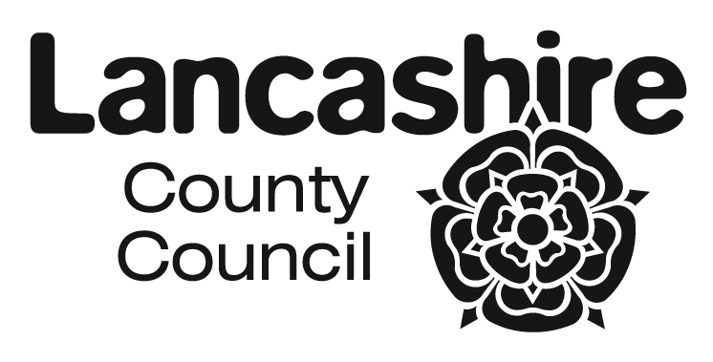
FREE SCHOOL MEALS
APPLICATION FORM

Please complete in block capitals

Benefit Claimant's Name (Mr/Mrs/Miss/Ms)
Benefit Claimant's Date of Birth
Benefit Claimant's NI Number
Address
Postcode
Email address
Phone/mobile

Pupil Surname | Pupil First Name | M/F | DOB | School attended

Please answer all of the following questions (see notes for guidance overleaf) Please Circle
I am the parent/legal guardian of the child/children above and receive benefits for them | Yes | No
I receive Income Support or Income Based Job Seekers Allowance | Yes | No
I receive Income Related Employment and Support Allowance | Yes | No
I receive Child Tax Credit, my annual income is less than £16,190 and I don't receive Working Tax Credit * | Yes | No
I receive the Guarantee Element of State Pension Credit | Yes | No
I receive support under Part VI of the Immigration and Asylum Act 1999 | Yes | No

* If you are entitled to Working Tax Credit you will not qualify for Free School Meals (subject to Note 7 overleaf).

Claimant's Consent to check eligibility for Free School Meals via the Department of Education Free School Meals Eligibility Checking Service (ECS)

I agree to Lancashire County Council checking my details with relevant government departments or other agencies to assess my initial and ongoing entitlement to free school meals, free travel to school and free school milk.

FOR OFFICIAL USE ONLY
Outcome
Date
Checked by
Household ID

Signed ..........................................................................

Authorised over the telephone? (tick)

Date ........................................................

APPLICATION FOR FREE SCHOOL MEALS
NOTES FOR GUIDANCE
If you receive:

1. Income Related Employment and Support Allowance
2. Income Based Jobseeker's Allowance
3. Support under Part VI of the Immigration and Asylum Act 199
4. Guarantee Element of State Pension Credit
5. Child Tax Credit (BUT NOT entitled to Working Tax Credit and your annual income does not exceed
£16,190)
6. Working Tax Credit 'run on' – the payment you receive for a further four weeks after you stop
qualifying for Working Tax Credit
7. Universal Credit (sometime during 2014/15 this new benefit, if fully introduced by the Government, will
also be a qualifying criteria for free school meals)

Then your children will be entitled to free school meals if they are attending maintained schools and academies and are under 16 years of age on 1st September in the school year. In addition, nursery aged pupils, attending maintained nurseries, who receive education before and after lunch will also qualify for free school meals if their parent/carer is receiving one of the above qualifying benefits.

From September 2014 all KS1 pupils will receive free school meals, however only those pupils on the above qualifying benefits need to register for the meals by completing this form. These qualifying parents are encouraged to apply since the school attended will benefit from this additional funding, called Pupil Premium, for all those who register.

Pupils over 16 attending special schools or school sixth forms will be entitled to free school meals if they, or their parents, receive the above benefits. From September 2014, students over 16 and attending sixth form colleges or colleges of further education will also be entitled to free school meals if they or their parents are receiving all of the above benefits. These students though need to apply direct to the sixth form college or college of further education.

The County Council is now able to access the Government's benefits eligibility database which will enable an immediate check on your entitlement to free school meals without you needing to produce documentary evidence, provided you complete the declaration overleaf. Please be aware that it may take up to 15 working days for your eligibility for benefit to register on the database.

You do not need to complete an application form on an annual basis. Once your children have been awarded free school meals they will continue to receive them throughout their school career unless they cease to be entitled. This automatic entitlement will cease at the end of their Y11. If the pupils are moving into the school sixth form then you will need to apply again. You must though advise the County Council immediately if you change address or your financial circumstances change and you are no longer entitled for free school meals for your children.

CONTACT DETAILS FOR EDUCATION OFFICES
(The information below is correct as at 3 March 2014)

 | NORTH AREA  Lancaster, Wyre & The Fylde | SOUTH AREA  Preston, South Ribble,  West Lancashire & Chorley | EAST AREA  Burnley, Hyndburn / Ribble Valley,  Pendle , Rossendale
 | Area Education Office  White Cross Education Centre  Quarry Road  Lancaster LA1 3SE  (01524) 581207 | Area Education Office  Joint Divisional Offices  East Cliff  Preston  PR1 3JT  01772) 531809 | Area Education Office  44 Union Street  Accrington  BB5 1PL
  If you live in ...
  Ribble Valley | (01254) 220715
  Hyndburn | (01254) 220714/17
  Burnley | (01254) 220708
  Pendle | (01254) 220710
  Rossendale | (01254) 220711

