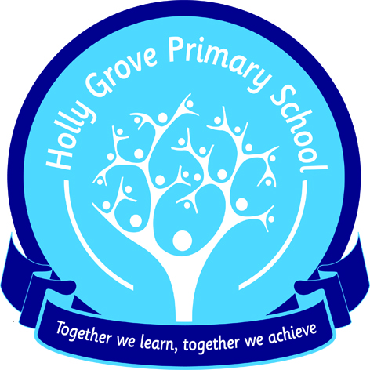
Holly Grove Primary School
Burnley Campus
Barden Lane
Burnley
BB10 1JD

Telephone: 01282 682278
Fax: 01282 682281

Headteacher: Karen Alty Deputy Headteacher: Eve Taylor

FREE SCHOOL MEALS FOR KEY STAGE 1 PUPILS

All pupils in Key Stage 1 are entitled to receive a free school meal as part of a government initiative.

If you would like your child to receive a free school meal please can you let us know by completing the reply slip attached and returning to school as soon as possible.

It is very important for those pupils who have a statutory entitlement to free school meals i.e. those children whose parents/carers are in receipt of certain benefits that you still register with the local authority. By registering, the school can benefit from additional funding called Pupil Premium. This is worth over £1000 per pupil so it is vitally important that if you would have been entitled to free school meals you still register your child. (Please see additional form)

To register, or for information on statutory free school meals, please contact the Area Education Office, 44 Union Street, Accrington, BB5 1PL, Telephone number 01254 220708.

………………………………………………………………………………………………

Childs Name: ……………………………………………………………………………………………………………………

Please tick :

I would like my child to receive a KS1 free school meal

I do not wish my child to have a KS1 free school meal

Signed: ………………………………………………………………………………………………….. Date: ………………………………………
Parent/Carer

