**Subject Report**

**Teacher: Laura Byrne Subject: Computing Date: May 2024**

*Computing / ICT at Holly Grove School is aimed to enhance our children’s learning about computer technology as its use is widespread throughout the world today and is likely to become more so before our children mature and leave school.*

At Holly Grove School, we follow our own Scheme of Work (re-written in September 2023 in line with the National Curriculum’s Computing programmes of study), which incorporates the three strands of Computing – Computer Science, IT and Digital Literacy (including Online Safety). The mapping grids have also been updated for each year group and during Autumn 2023, I shared ‘I can statements’ to ensure progression across Phase 1 to Year 3 with all the teaching staff to assist with their planning. The Computing assessment tool (written in 2021) is used to measure children’s annual progress and all children have progression maps to track their progress in other areas of Computing / ICT i.e. cause and effect, iPads, keyboards, online safety.

We have continued to purchase resources to maintain and enhance our curriculum with hardware, software and subscriptions i.e. iPads, iPads cases / cables, ClassVR, EyeGaze, Discovery Education and Coding, Purple Mash, Classroom Secrets and Twinkl. We were also very excited to share our ‘Transform Education with Choose It Maker’ video, made in partnership with Inclusive Technology in exchange for free access to a package that includes Helpkidlearn, Choose It Maker and Choose IT Ready – all invaluable programs to aid communication and give children a voice. Classes also continue to access the multi-sensory studio at least once per week and have unlimited access to the ICT / Communication store for talk tiles, switches, cause and effect toys etc.

In February 2024, the whole school celebrated Safer Internet Day. Each class engaged in extra-fun learning activities about how to be safe online including creating avatars, re-capping online safety rules (see overleaf), partaking in quizzes and making posters / displays about being safe online. A special ‘Online Safety’ edition newsletter containing advice / support about online safety was also distributed to parents. There continues to be a strong whole school emphasis towards online safety and to ensure parents feel fully supported in this area, we provide regular updates about online safety and signpost them to free advice / resources from reputable websites via our school website and our school FaceBook page. I have also continued to attend the ‘Nibble and Natter’ sessions for parents / carers led by Shagufta Nasir, to discuss, answer questions and share information about keeping children safe online. Additionally, I will be delivering an online safety parent forum Thursday 6th June 2024.

Computing Photographs

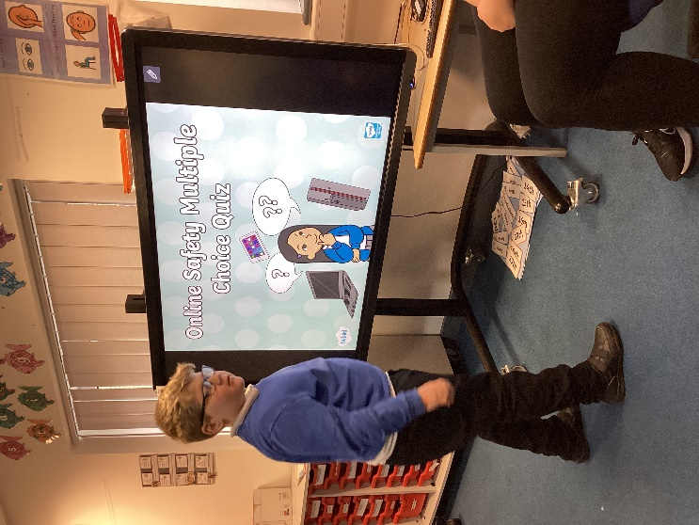 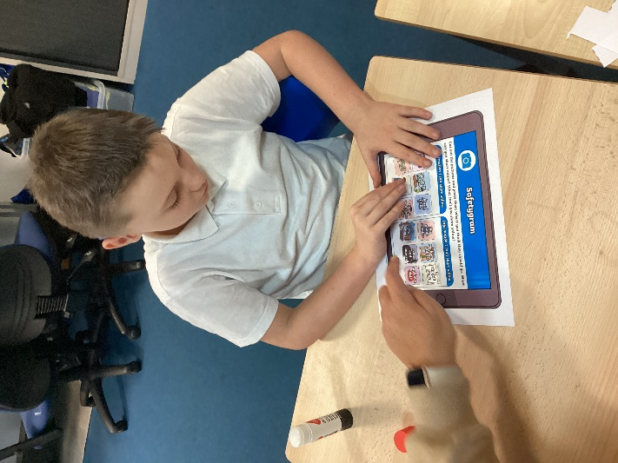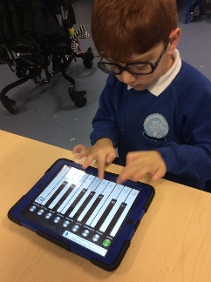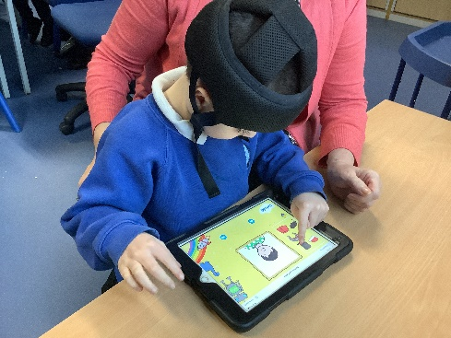

**Online Safety Rules**

• *Do not use the internet without an adults permission.*

• *Do not download a file or a picture without checking with an adult first, it could be a virus.*

• *If a stranger talks to you online, be safe and tell an adult.*

• *Do not give out your personal details online, like full name, date of birth, address or password.*

• *Be kind online and respect other people.*

• *Do not agree to meet anyone you have been talking to online.*

• *Always tell an adult you trust if you see anything that makes you feel scared, uncomfortable or confused.*