**Subject Report**

**Teacher: Courtney Fourie Subject: Creative Arts Date: 2023-2024**

**Food Technology**

This year has been transformative for our Food Technology curriculum. The newly equipped kitchen in Upper School and the refreshed Lower School equipment provides safe, practical environments where children can practice their culinary skills. These spaces are now fully functional and sustainable, equipped with necessary appliances and tools to support an engaging learning experience.

Weekly access to the revamped Food Technology room has significantly boosted engagement and learning outcomes. Children have been enthusiastically preparing a variety of healthy, delicious dishes. Beyond culinary skills, our curriculum focuses on equipping children with vital life skills, such as planning, time management, teamwork, problem-solving, and understanding nutrition. These skills are designed to benefit them in their daily lives.

**Art and Design Technology**

This year, we have redesigned our mapping grids to accommodate new classes and link to their topics, allowing for cross-curricular activities that ensure a balanced and creative curriculum. Each half term, children focus on either Art or Design technology, providing ample time to explore and develop their skills in both areas. Significant investments have been made in acquiring new resources to support artistic techniques and mediums. Termly evaluations of existing resources have guided these acquisitions, enhanced the teaching, and learned experiences in Art.

Each class has had the opportunity to focus on an artist, including both famous and modern/current artists. This approach has enriched our Art curriculum, allowing children to gain a broad perspective on various artistic styles and techniques.

To celebrate our children’s' artistic achievements, we have continued both a termly Art gallery in the corridor and online, showcasing the children’s artwork. These exhibitions, in collaboration with the children, create visually engaging displays that inspire the entire school community and wider community. Recognising the importance of integrating Art across the curriculum, we have implemented cross-curricular displays showcasing children’s artwork alongside other subject areas. This approach helps children understand the relevance and applicability of Art in their broader education.

**Future Plans**

Looking ahead, we are planning to invite an Artist for the spring term, allowing children to access specialist art expertise. Additionally, staff training for food hygiene is planned to ensure that each class accessing the Food Technology room is well-equipped to maintain safety standards.

Overall, we are exceedingly proud of the achievements our children have made this year in both Design Technology and Food Technology. Their growth and the remarkable work they have produced are a testament to their resilience, creativity, and hard work. We are excited to continue supporting them on this journey of learning and discovery in the coming year.

We look forward to another year of innovation, creativity, and outstanding achievements in the Creative Arts at Holly Grove Primary School.

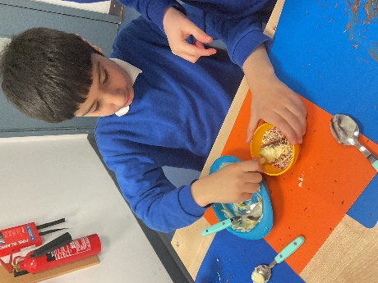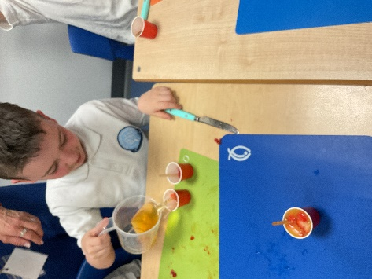**Evidence of our Creative Children**

