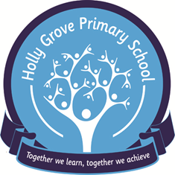

Home / School Agreement

We believe that each child is a unique individual. We want every one of our children to experience an exciting and challenging curriculum that will help them reach their potential.

School will:

- Provide a safe and caring environment.

- Encourage children to develop a sense of responsibility.

- Regularly report on your child’s progress in school.

- Let parents know about any concerns or problems that might affect their child’s work or behaviour.

- Welcome parents into school at all times.

- Keep parents informed about school activities.

Family will:

- Ensure that their child attends school.

- Support their child in home learning.

- Try to attend Reviews and Parents’ Evenings.

- Let the school know about any concerns regarding their child.

- Become familiar with their child’s school life

- Keep the school informed of any reason for absence in writing

- Send their child to school in suitable clothing and with appropriate equipment.

Together we will:

Support the child’s learning to help them achieve their best and encourage them to participate fully in school life.

Signed: ...………………………………………............. Date………………………….......................…
on behalf of Holly Grove School

Signed: ..………………………………………................ Date………………………......................…….
on behalf of the family

Child’s Name ……………………………………………………………………………………..................................…

